Writer’s Notebook Term 3 Week 5
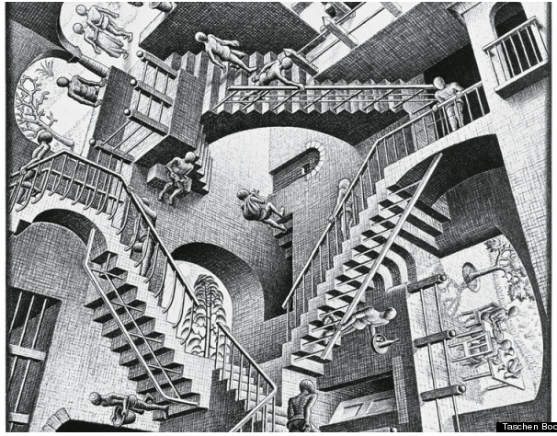
- How does perspective affect the image?
- What is Hiram’s perspective about segregation and Jim Crow laws in chapter 7 while talking to Mr. Paul?
- How is Mr. Paul’s perspective different?
- Do you think Hiram’s perspective will change, or will he and Mr. Paul remain on “separate staircases”?
- Story Starter-Choose a figure from the drawing and write their story. Who are they? What time period is it? What country/planet are they on? Do they know they know about the other staircases? Be creative!

